RA2011028010058

SHARDUL BHARDWAJ

EXP NO: 6

Querying Data in S3 with Amazon Athena

**Aim**: Querying Data in S3 with Amazon Athena

Step 1:

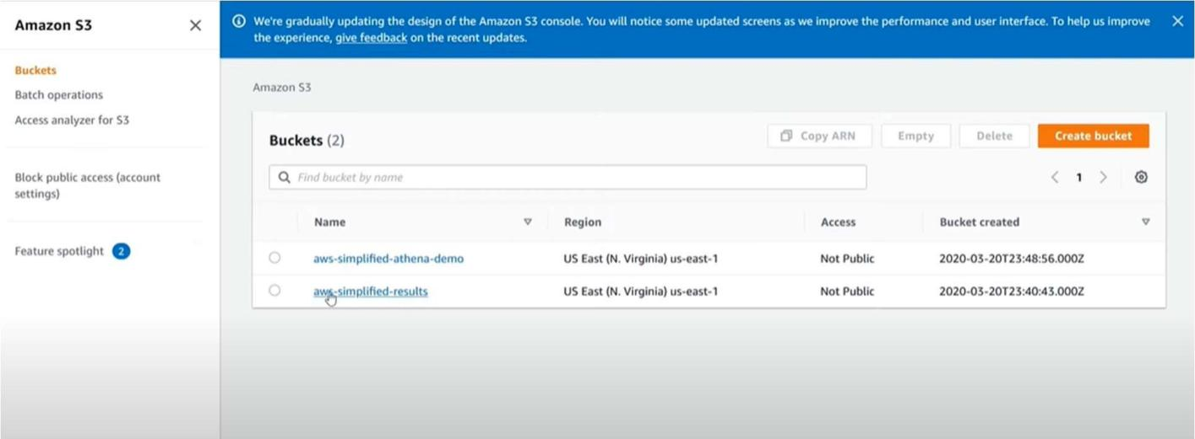Go to buckets and create two buckets.

Step 2 :

After clicking onto the bucket add files to it.

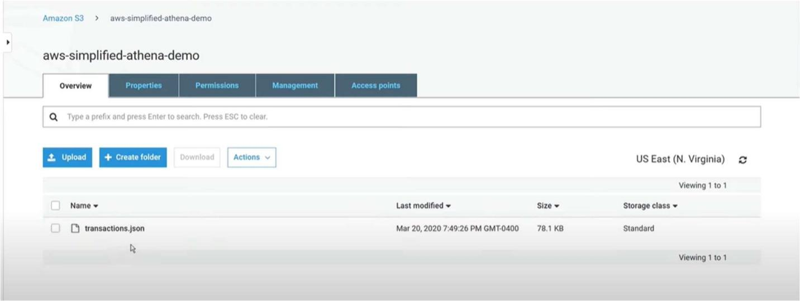

Step 3 :

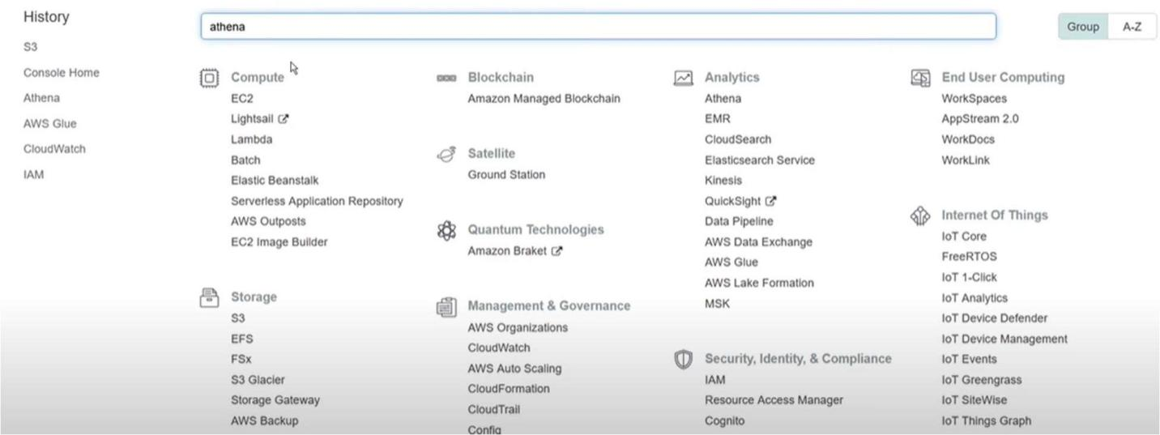Now go to Amazon athena.

Step 4 :

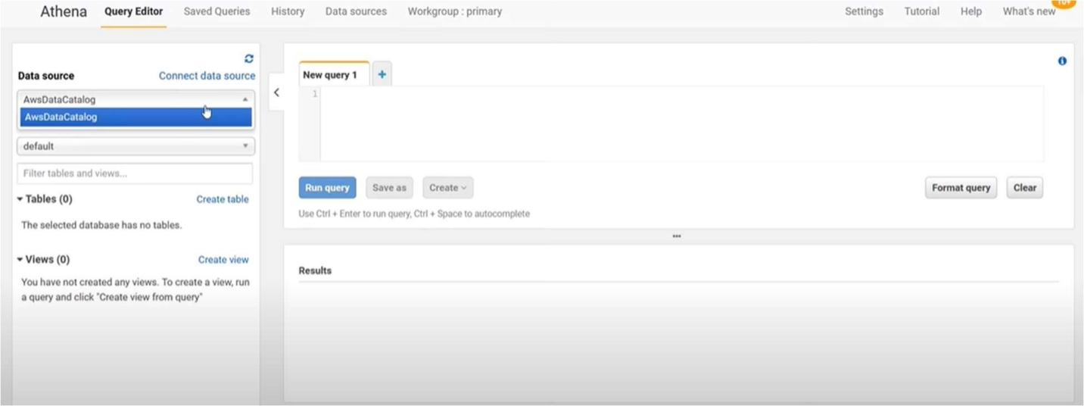Select AwsDataCatalog in the left side which is present in the data source tab.

Step 5 :

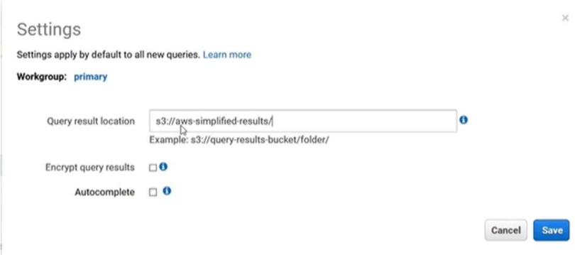After that go to settings and specify an output path.

Step 6:

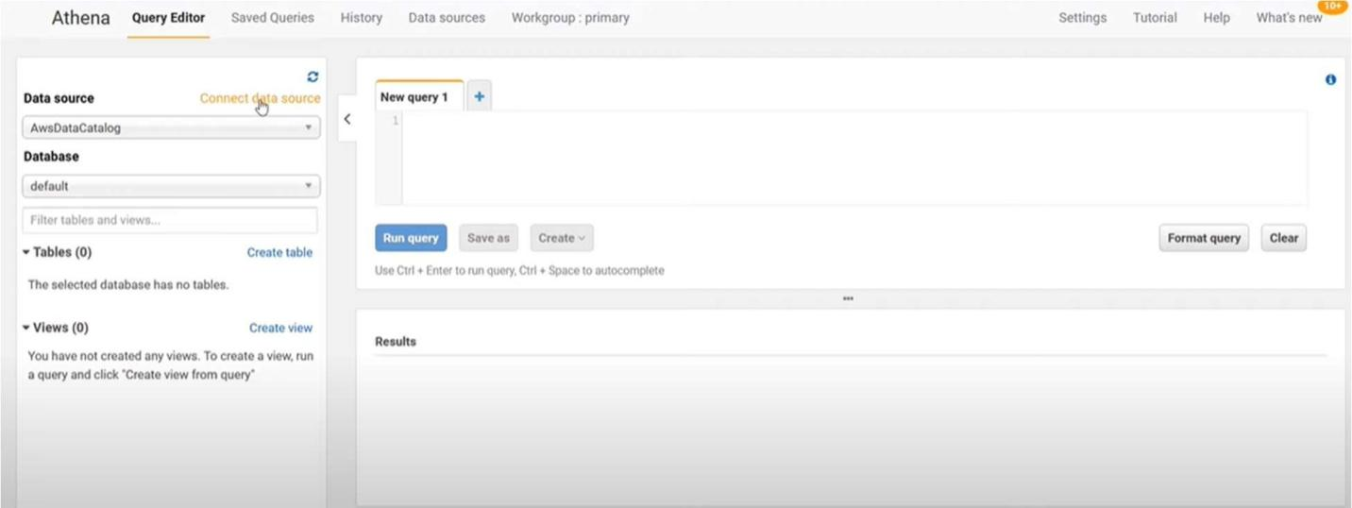Click on connect data source.

Step 7:

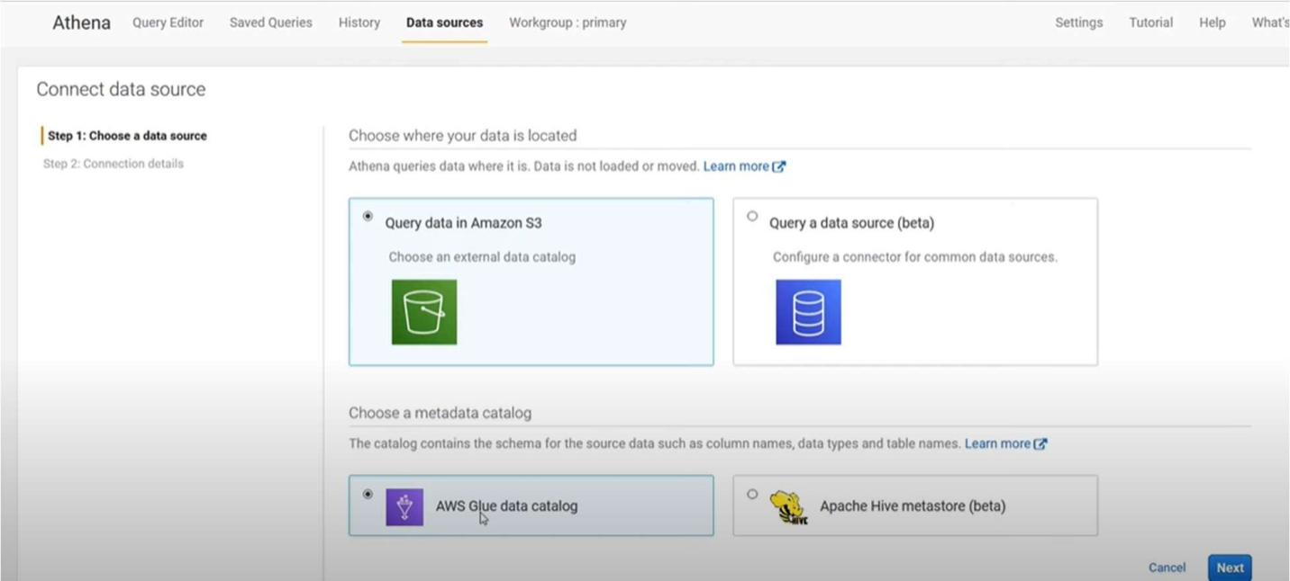After clicking choose a query in amazon s3 and Aws glue data catalog.

Step 8:

Click on next and select setup a crawler in AWS glue to retrieve schema information automatically.

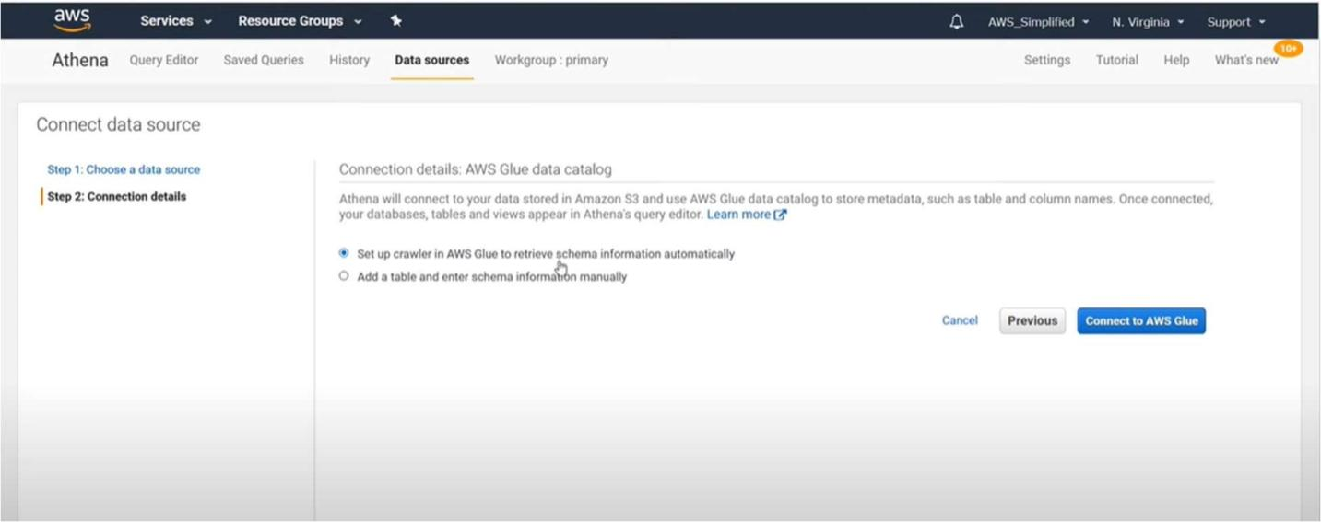

Step 9: After selecting that it will redirect to

a new page and add crawler and follow below steps to add a new crawler after setting up click on finish.

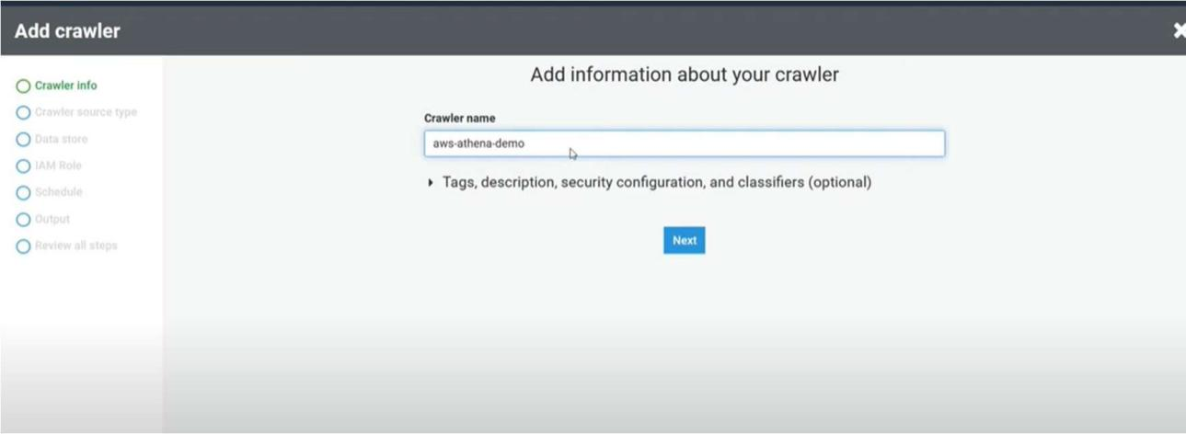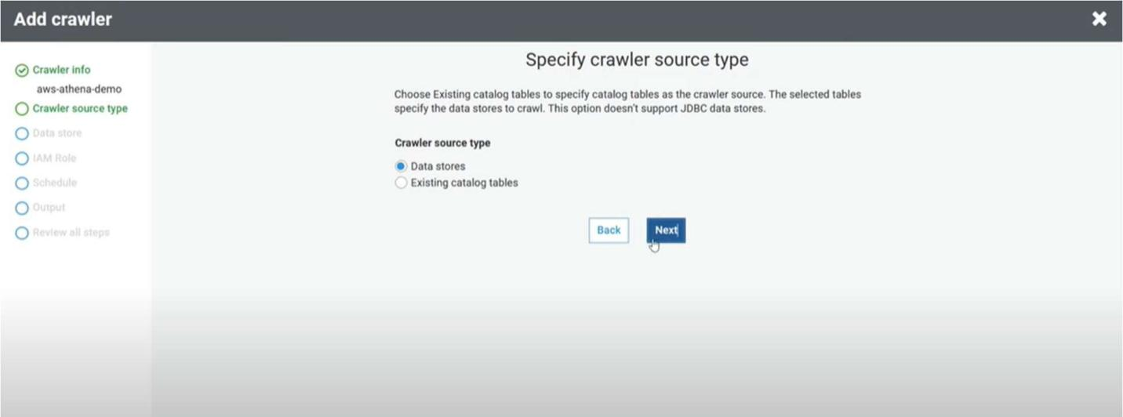

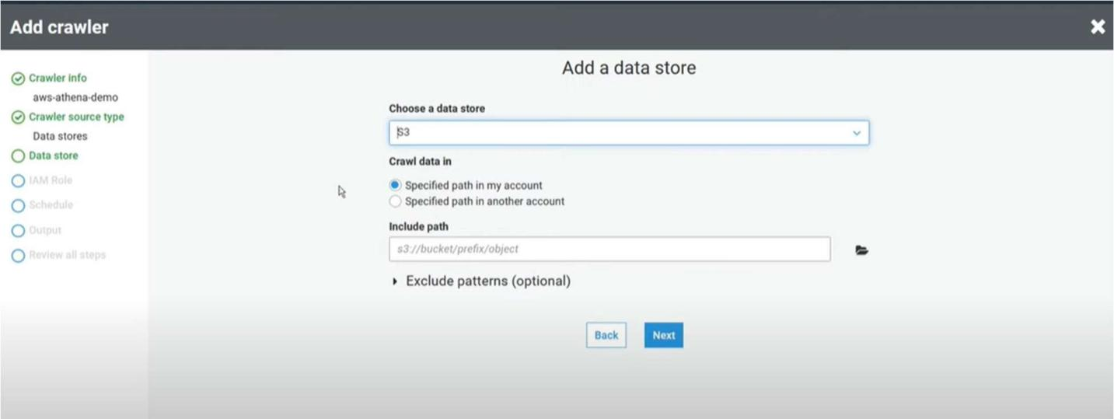

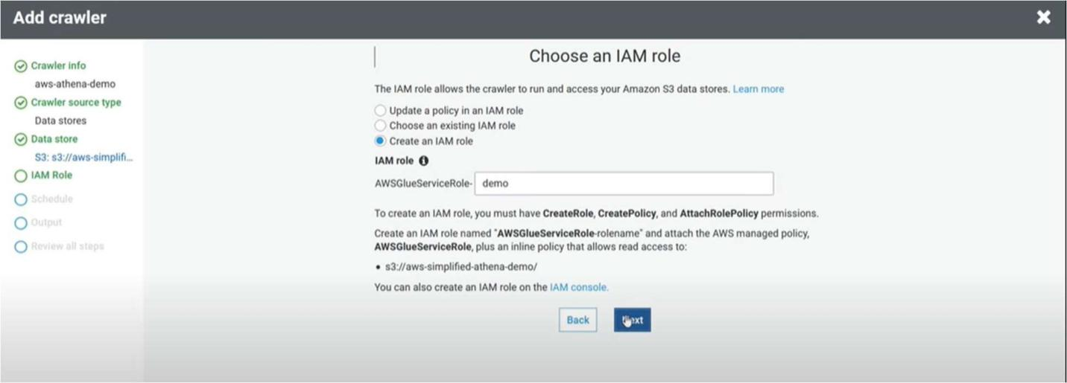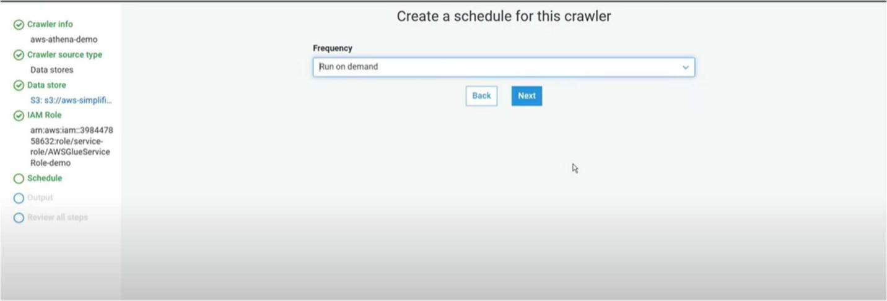

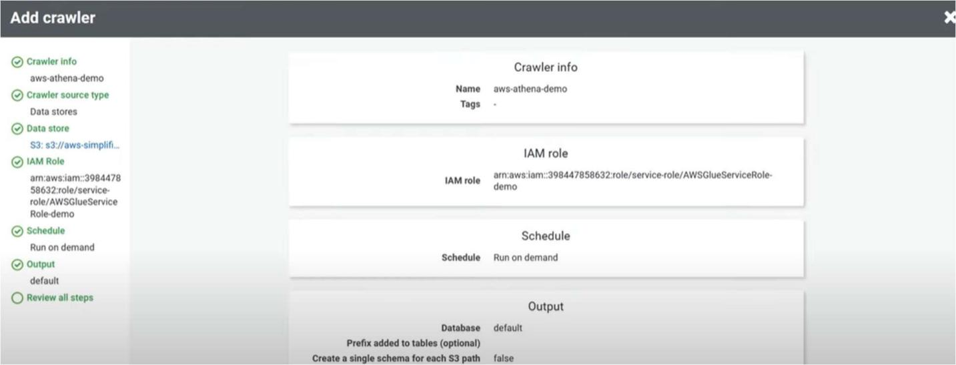

Step 10:

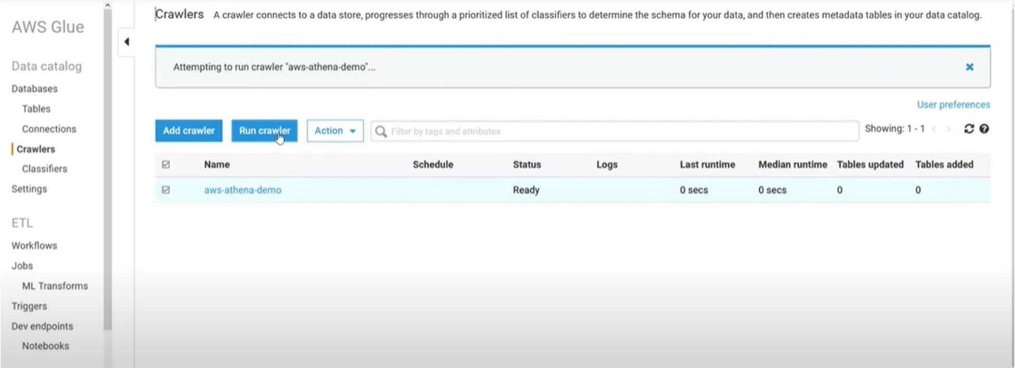Crawler is successfully created and now click on the crawler and click run crawler.

Step 11:

After running the crawler go back to athena you will see a table created on table column select that and click on preview table.

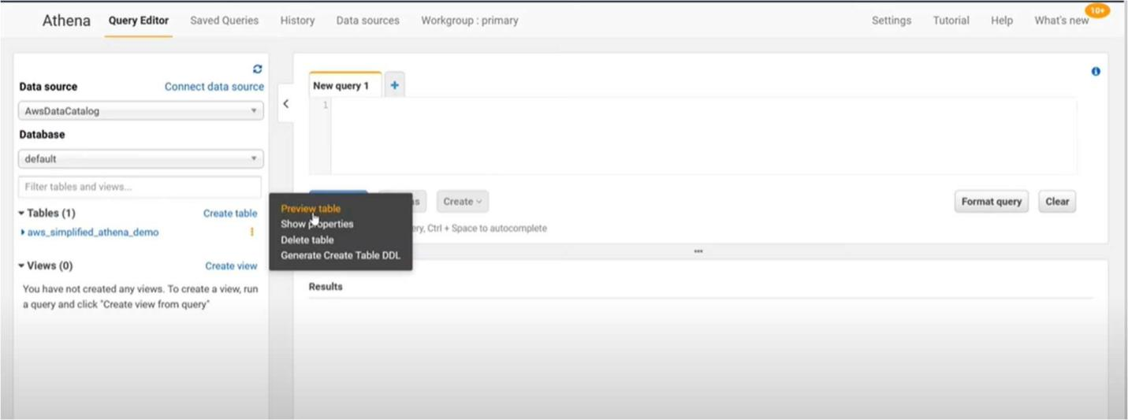

Step 12:

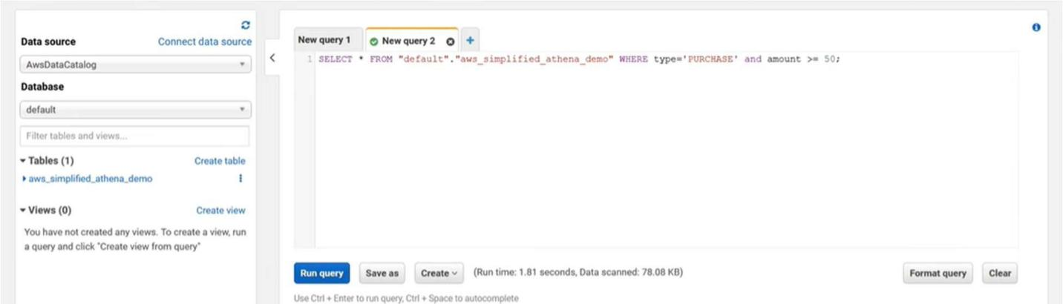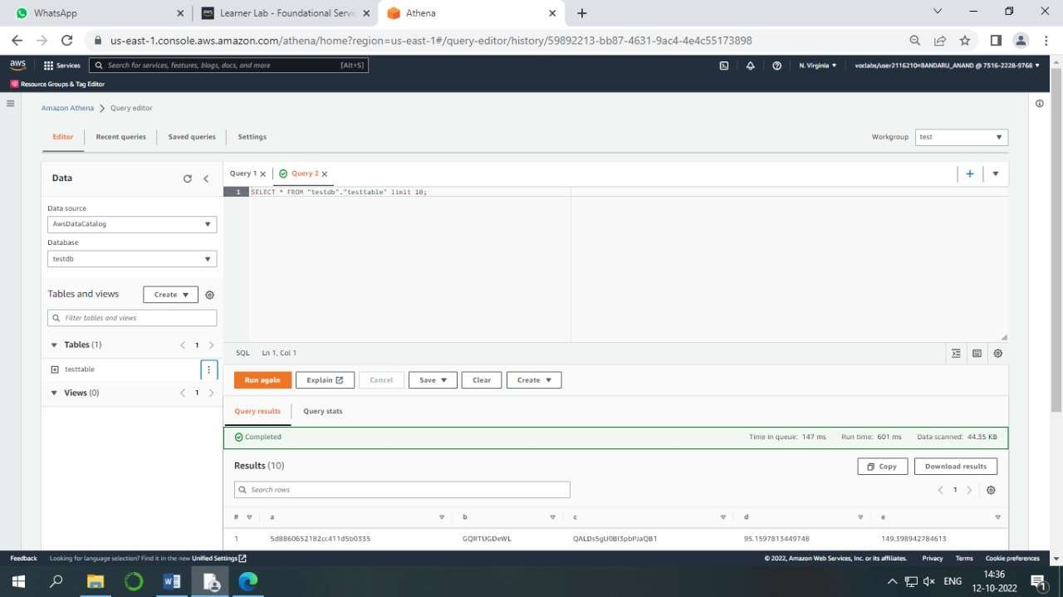Now the query can be executed.

RESULT:

Querying Data in S3 with Amazon Athena is done and output is verified.